**Dominic Townsend’s Programming Tutorials**

**Timer System**

1. Create a TextMeshPro object called “Timer”.

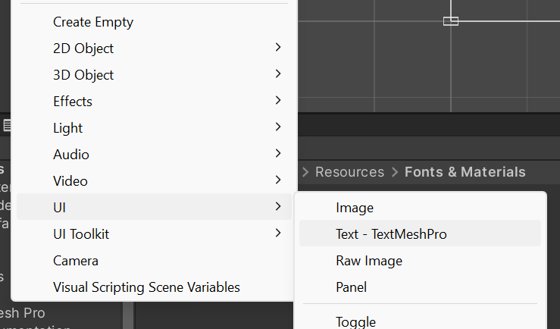

2. In the Canvas settings, set the UI Scale Mode to “Scale With Screen Size”, the Reference Resolution to 1080p and the Match value to 0.5.

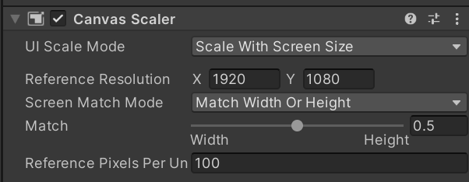

3. Adjust the size and position of the text box, and the properties of the text itself.

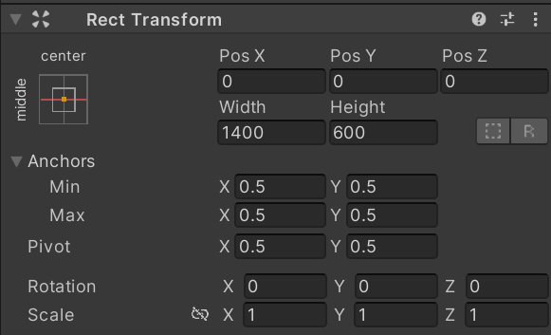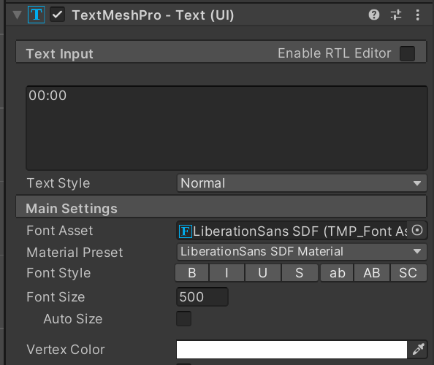

4. If done correctly, the TextMeshPro should look something like this:

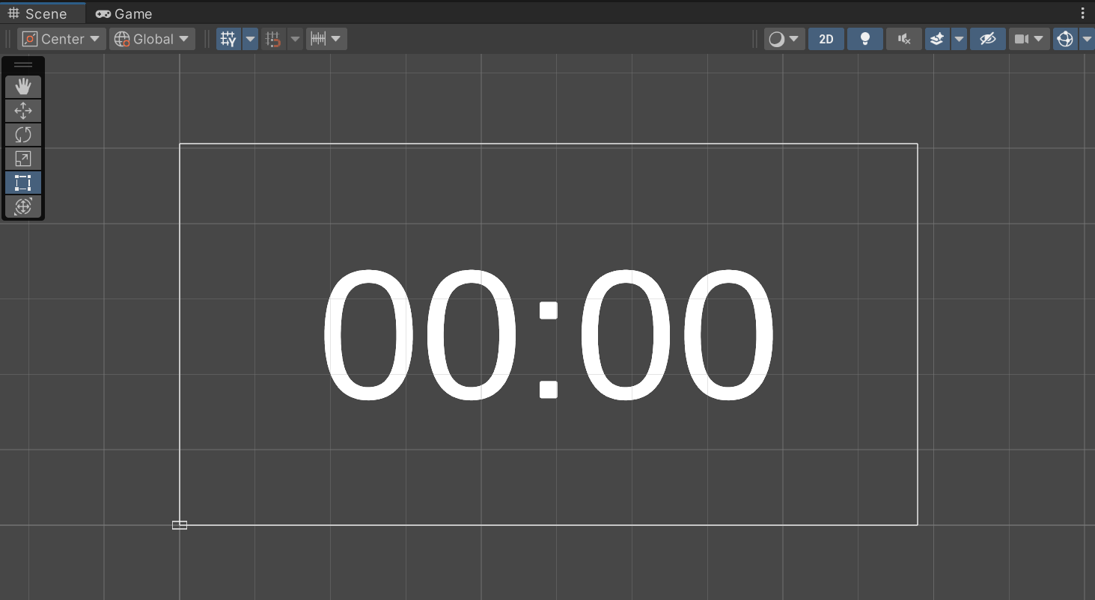

5. Create a C# script called “TimerSystem.cs”, and attach it to the TextMeshPro object.

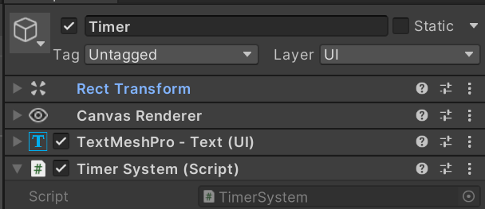

6. Write the following code. Make sure to add “using TMPro”, as this isn’t present by default.

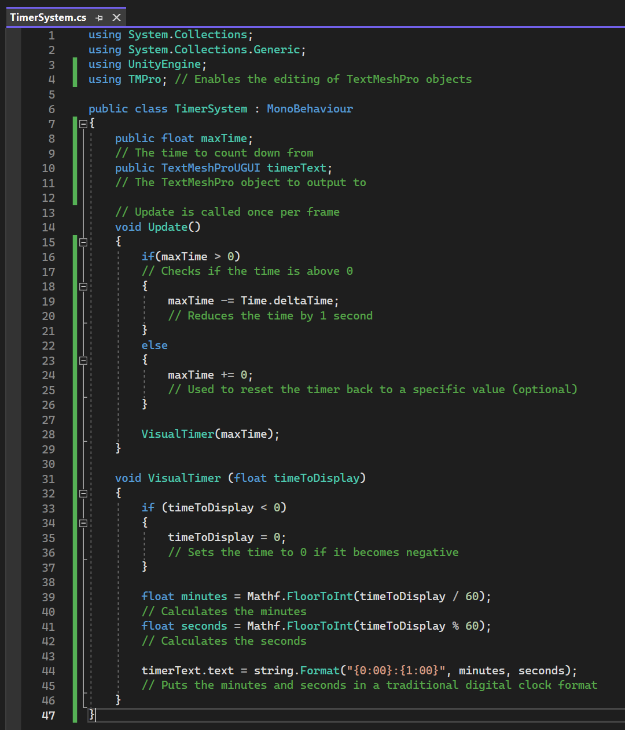

7. In the attribute editor, set the Max Time to the time to count down from, and the Timer Text to the TextMeshPro.

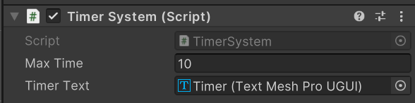

8. When testing the project, the timer should now count down from whatever time you set and stop at zero.

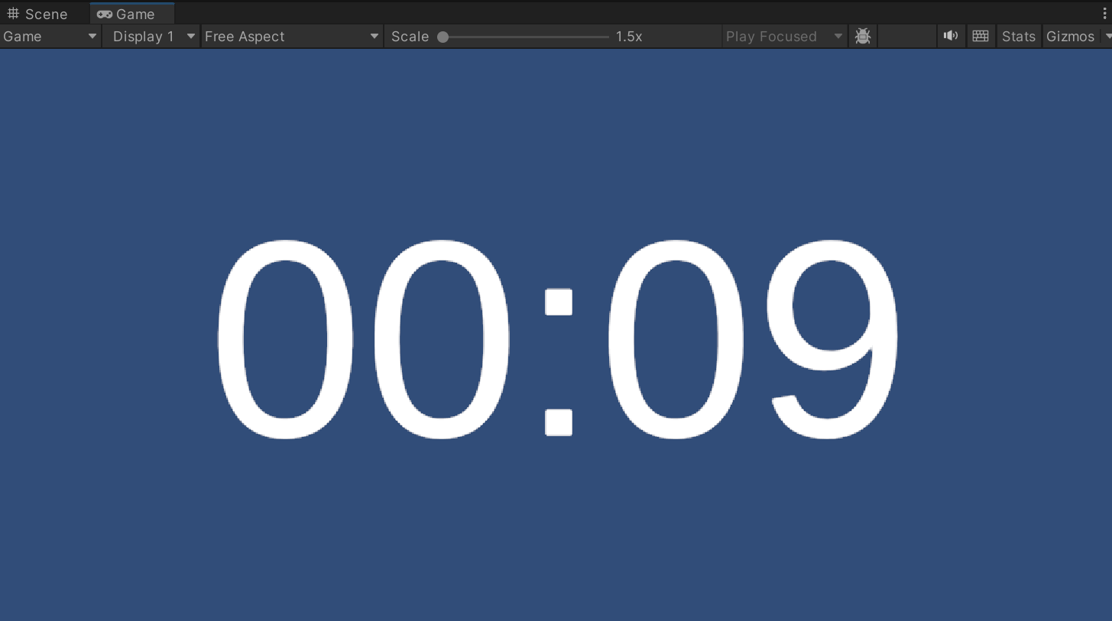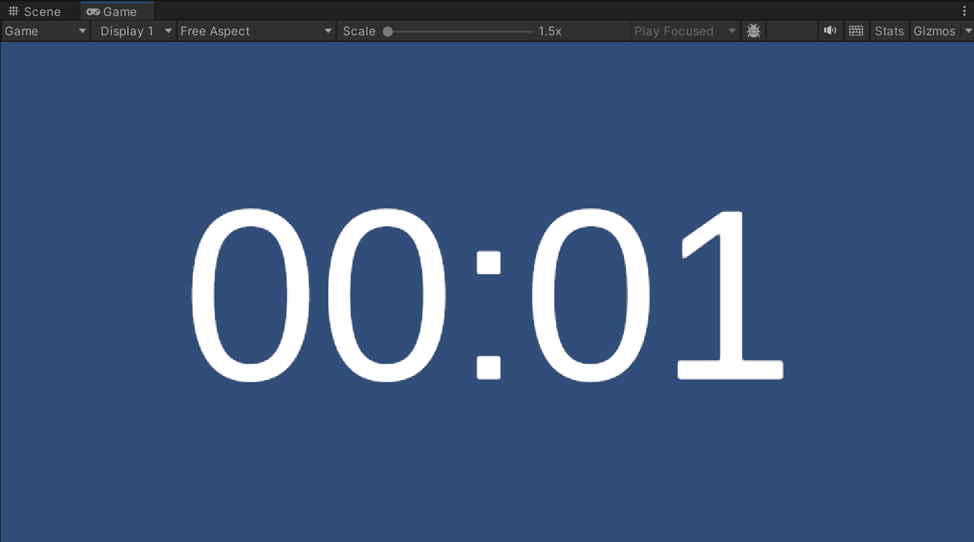

9. The following steps are for changing the timer’s font. Start by going to Window > TextMeshPro > Font Asset Creator.

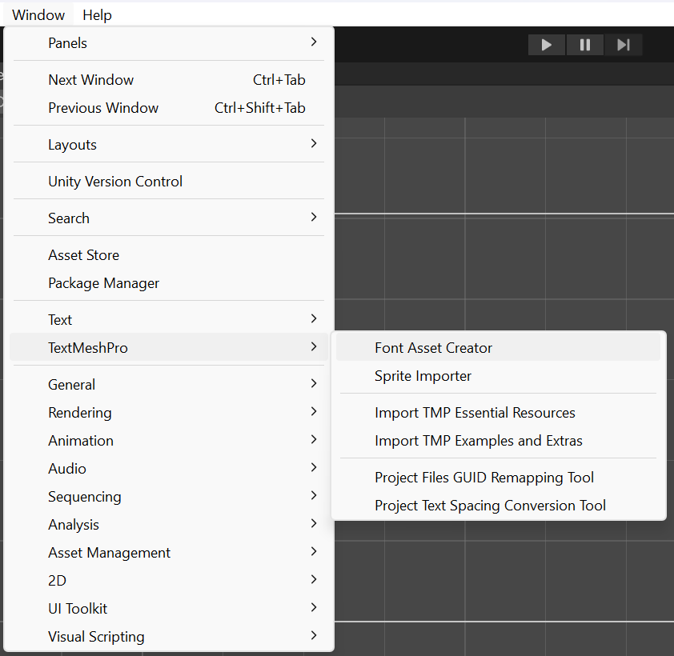

10. Find a .ttf file for the font you want to add, move it into the assets folder and select it from the Source Font File menu. Click Generate Font Atlas, and save the font.

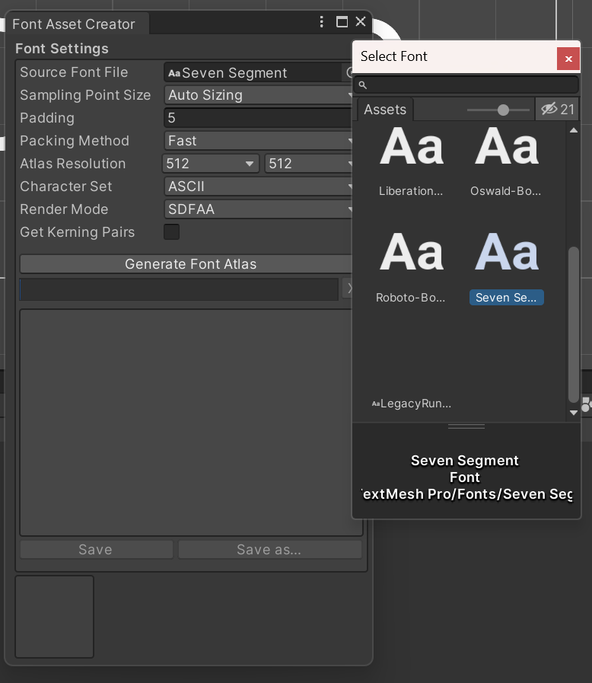

11. Select the font in the attribute editor of the TextMeshPro.

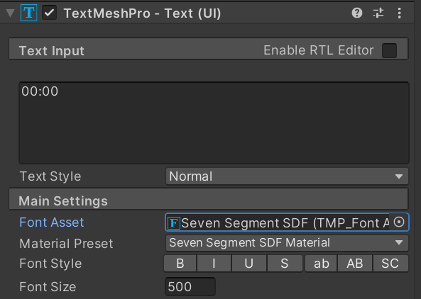

12. The timer should now have your new font. You can make any further adjustments (e.g. font colour) until the desired outcome is reached.

